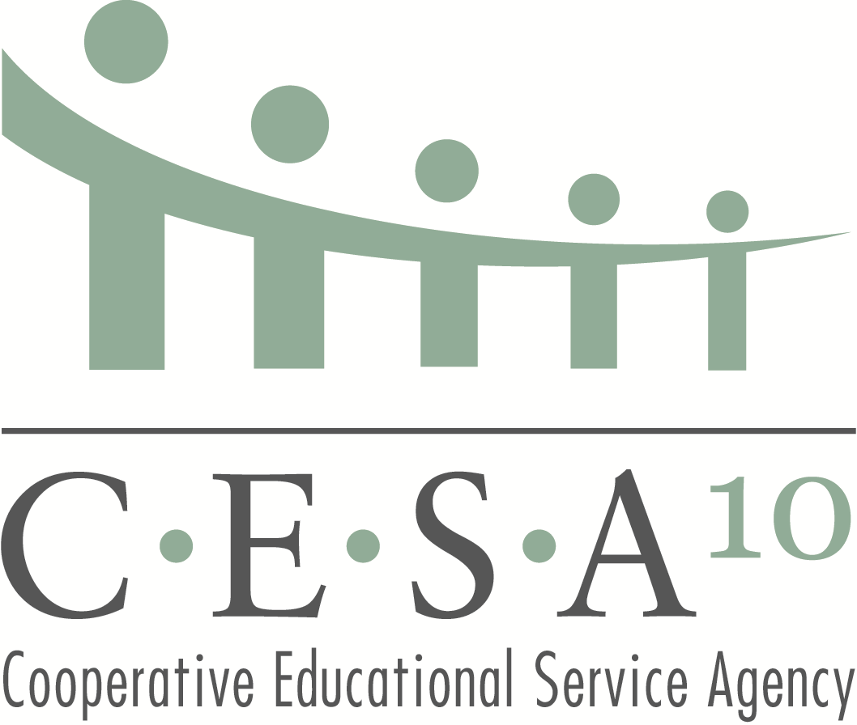
725 West Park Avenue Chippewa Falls, WI 54729 715.723.0341 715.720.2070 (fax)
Where service and leadership unite

Bookkeeper’s Meeting Agenda
September 30, 2015

- 8:45-9:00 Fruit and Juice; Converse with peers

- 9:00-9:05 Introductions

- 9:05-9:45 CESA Department Updates
        - Instructional Services – Perkins and Youth Apprenticeship Funding
        - Special Education – Changes for 15-16 in High Cost Aid, Open Enrollment Fees and Categorical Aid
        - Operations – 15-16 Service Contracts; WRS Rates for 2016

- 9:45-11:30 ACA Reporting Presentation (Deb Svihovec, Sr. Benefits
Consultant, Associated Financial Group)

- 11:30-11:45 Wrap-up

